PRINTS-A000-EUR-Italy-Rome-Tiber Island-Patouillard-1910

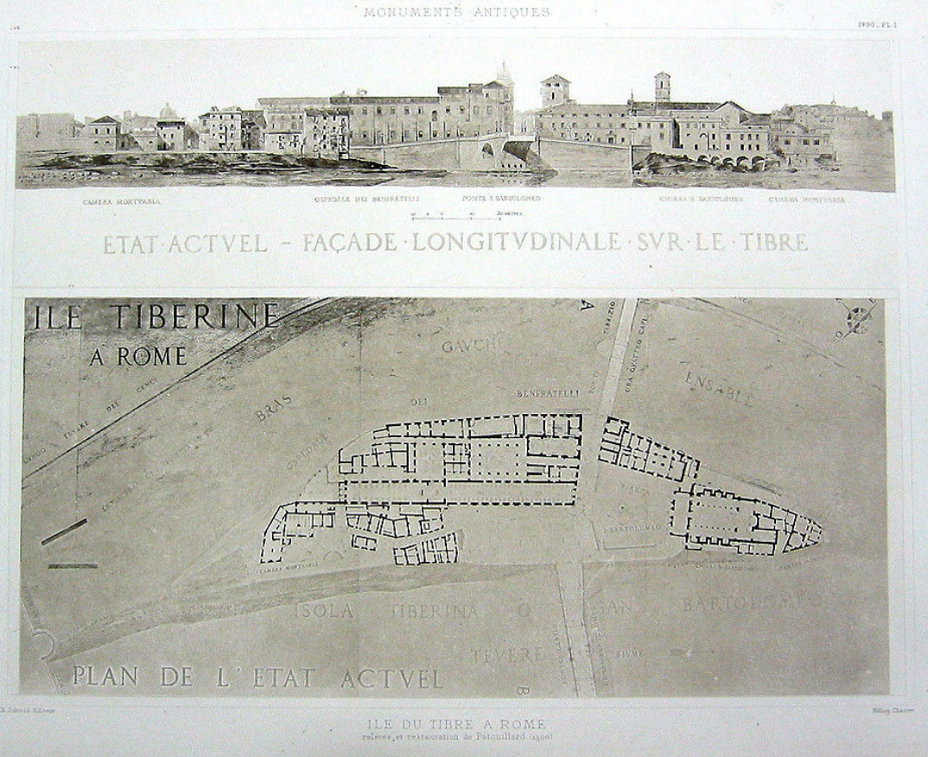

|  |
| --- |
| **PRINT DATE:**  This lithograph was printed in 1910 from an original restoration work completed by the artist in 1900. |
| **PRINT DIMENSIONS:**  12 inches by 17 inches |
| **PRINT CONDITION:**  excellent condition, specifically as shown in this detailed scan. |
| **PRINT TYPE:**  Heliogravure print (see description of process in our Glossary). |
| **PAPER TYPE:**  Thick rag stock cardboard type paper. |

**BACKGROUND INFORMATION AND HISTORY ABOUT THE SUBJECT OF THIS PRINT :**

The course of the river Tiber draws a double bend through the center of Rome; at the southmost part of the bend is a small isle, called the Tiber Island, less than 400 yards in length and no wider than 100 yards. It has the typical shape of a vessel; this has inspired the legend according to which the island rests on the site of a sunken ship. The island had several temples dedicated to various divinities, but the most important temple was that of Aesculapius (god of medicine) whose location corresponds to that of the church of S. Bartolomeo. History records that the temple of Aesculapius was built between 292 and 299 BC on the spot where a serpent had disappeared after having escaped from a ship returning from the sanctuary of Epidaurus in Greece, where an embassy had gone in order to seek an end to a plague infecting the city. Surviving inscriptions and ex-votos show that Tiber Island was a place of healing. Today the island is still the site of hospitals.

The Pons Fabricius, today Ponte Quattro Capi, connects Tiber Island to the Campus Martius near the Theater of Marcellus. It consists of a central pier and two arches with a span of about 24.5 meters. Inscriptions on the bridge and ancient texts allow us to date construction precisely to 62 BC. It was restored in 23 BC after a great flood. The Pons Aemilius, which connects the Forum Boarium to Trastevere, was constructed in two major stages: the piers by the censors of 179 BC and the arches by those of 142 BC, L. Mummius and Scipio Aemilianus (whence the name of the bridge). Still partly in place, it is today called Ponte Rotto, " broken bridge."

The Tomb of Hadrian is still visible today since it corresponds to the Castello S. Angelo. In the burial chamber of this monument, constructed by Hadrian in 130-139 AD (then finished after his death), the burial urn of the emperor was deposited. All of the emperors of the Antonine dynasty, as well as the Severans up to Caracalla, were buried here. The tomb was richly adorned with epitaphs and statues of marble (including a giant Antoninus Pius) and of bronze (a four-horse chariot bearing the figure of Hadrian at the summit of the central podium). The structure of the Tomb of Hadrian has been of interest to military strategists (the statues served as projectiles during the attack of the Goths in 537 AD) and the building was transformed into a castle, probably in the ninth century.

**INFORMATION ON THE HISTORY OF THIS PRINT**: Louis XIV, the King of France, was a generous patron of the arts. During his long reign (1643-1715), he sought to raise standards of taste and sophistication in the Arts and so a number of royal academies were founded, including the Academy of Painting and Sculpture (1648), the Academie de France in Rome (1663) and the foundation of the Academie royale d'Architecture (1671). This formalized a system for the training of French architects and by elevating artisans to academicians, the power of the medieval guilds was eroded and centered instead on the patronage of the king. Subsidized by the state, the Academy of Architecture was free to those, aged fifteen to thirty, who could pass the entrance examinations. By the nineteenth century, students were obliged to complete a number of increasingly demanding concours or competitions, the most prestigious of which was the Grand Prix de Rome, a rigorous annual examination (a first competition was in 1702, then 1720, then yearly) that provided the winner advanced study at the French Academy in Rome at the Villa Medici, where classical antiquities could be seen at first hand. Each year, for the four or five years they were in Rome, the students, supported financially with pensions, (hence their name of pensionnaires) were required to produce two sets of drawings, or envois, of Rome's ancient and medeival monuments: the état actuel, which was an exacting representation of the extant state, documenting the site with the precision of an archaeologist, and the état restauré, a more imaginary and often idealized restoration including the rendering of shade and shadow, which was accompanied by a written description of the monument's antiquity and construction. Often times, the views of the architects differed from those of the archaeologists in that the students wanted to use such buildings as inspiration for their own work, and hence reconstructed them omplete and coloured, often at the disagreement of the archaeologists.

**Narcisse Théophile Patouillard** (2 July 1854 – 30 March 1926) was a French [pharmacist](https://en.wikipedia.org/wiki/Pharmacist) and [mycologist](https://en.wikipedia.org/wiki/Mycologist).

He was born in [Macornay](https://en.wikipedia.org/wiki/Macornay" \o "Macornay), a town in the department of [Jura](https://en.wikipedia.org/wiki/Jura_(department)). He studied in [Besançon](https://en.wikipedia.org/wiki/Besan%C3%A7on" \o "Besançon), then furthered his education at the École Supérieure de Pharmacie in [Paris](https://en.wikipedia.org/wiki/Paris), where in 1884 he earned a diploma with a doctoral thesis involving the structure and classification of [Hymenomycetes](https://en.wikipedia.org/wiki/Hymenomycetes" \o "Hymenomycetes) called "*Des Hyménomycètes au point de vue de leur structure et de leur classification*".[[1]](https://en.wikipedia.org/wiki/Narcisse_Th%C3%A9ophile_Patouillard#cite_note-1)

Patouillard was a practicing pharmacist for more than forty years, first in [Poligny](https://en.wikipedia.org/wiki/Poligny,_Jura" \o "Poligny, Jura) (1881–84), and later in [Fontenay-sous-Bois](https://en.wikipedia.org/wiki/Fontenay-sous-Bois) (1884–85), Paris (1886–1898) and [Neuilly-sur-Seine](https://en.wikipedia.org/wiki/Neuilly-sur-Seine) (beginning in 1898). From 1893 to 1900, he was *préparateur* to the chair of [cryptogamy](https://en.wikipedia.org/wiki/Cryptogam" \o "Cryptogam) at the École Supérieure de Pharmacie in Paris. In 1884 he was one of the founders of the [Société mycologique de France](https://en.wikipedia.org/wiki/Soci%C3%A9t%C3%A9_mycologique_de_France" \o "Société mycologique de France) and served as its third president in 1891-92. In 1920 he became an honorary member of the [British Mycological Society](https://en.wikipedia.org/wiki/British_Mycological_Society). He died in [Paris](https://en.wikipedia.org/wiki/Paris), aged 71.

Patouillard is highly regarded for his taxonomical work in mycology, and during his career, he described numerous genera and species of [fungi](https://en.wikipedia.org/wiki/Fungi). The following are some of the genera that he is the [taxonomic authority](https://en.wikipedia.org/wiki/Binomial_authority) of: [*Guepiniopsis*](https://en.wikipedia.org/wiki/Guepiniopsis), [*Hirsutella*](https://en.wikipedia.org/wiki/Hirsutella), [*Lacrymaria*](https://en.wikipedia.org/wiki/Lacrymaria_(fungus)), [*Leucocoprinus*](https://en.wikipedia.org/wiki/Leucocoprinus), [*Melanoleuca*](https://en.wikipedia.org/wiki/Melanoleuca) and [*Spongipellis*](https://en.wikipedia.org/wiki/Spongipellis). A mycological species called *[Inocybe patouillardii](https://en.wikipedia.org/wiki/Inocybe_erubescens" \o "Inocybe erubescens)* (brick-red tear mushroom) is one of the species named after him.

He was the author of nearly 250 works, and was a leading authority on tropical mycology. Over 100 of his publications involved studies of fungi from diverse locales such as [Brazil](https://en.wikipedia.org/wiki/Brazil), [Java](https://en.wikipedia.org/wiki/Java), [Guadeloupe](https://en.wikipedia.org/wiki/Guadeloupe), [Mexico](https://en.wikipedia.org/wiki/Mexico), [New Caledonia](https://en.wikipedia.org/wiki/New_Caledonia), the [Gambier Islands](https://en.wikipedia.org/wiki/Gambier_Islands), [Philippines](https://en.wikipedia.org/wiki/Philippines), et al.

Selected writings[[edit](https://en.wikipedia.org/w/index.php?title=Narcisse_Th%C3%A9ophile_Patouillard&action=edit&section=1" \o "Edit section: Selected writings)]

* *Tabulae analyticae Fungorum* (Analytic tables of fungi), 1883–1889.
* *Les Hyménomycètes d'Europe. Anatomie générale et classification des champignons supérieurs* (The Hymenomycetes of Europe. General anatomy and classification of the higher fungi) 166 pp. 1887.
* *Fragments mycologiques: Notes sur quelques champignons de la Martinique*(Notes on certain mushrooms of [Martinique](https://en.wikipedia.org/wiki/Martinique)) in Journal of Botany 3 pp. 335 - 343, 1889.
* *Essai taxonomique sur les familles et les genres des Hyménomycètes*
* 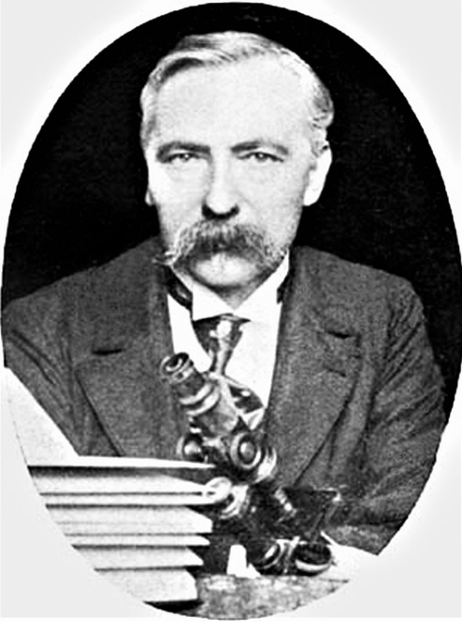
* Narcisse Theophile Patouillard (1854-1926) photographie prise par William Ashbrook Kellerman, publiée en 1906 dans *Ohio Mycological Bulletin*

The drawings submitted for the annual Grand Prix de Rome were on themes chosen by the Academy. The subjects set are indeed grand in scale and often in reach: triumphal arches (1730, 1747, 1763), palaces (1752, 1772, 1791, 1804, 1806), city squares and markets (1733, 1792, 1801), town halls (1742, 1787, 1813), law courts (1782, 1821) museums (1779) and educational institutions including libraries (1775, 1786, 1789, 1800, 1807, 1811, 1814, 1815, 1820) - all schemes for the promotion of civilization as the ancients would have understood the term. Stylistically, the entries usually share common characteristics: a grand Roman manner, with columns and orders, vaults and polychromy; an insistent and regular geometry, usually the square or the circle but sometimes the triangle; a penchant for the hemicycle, the propylaea and the pyramid; and finally a desire to impress by symmetry and the contrast between plain and decorated surfaces.

These ground plans (a drawing projected on a horizontal plane) and elevations (which was projected on a vertical plane) first were shown in Rome at the French Academy and then were forwarded to Paris to be shown to the members of the Academie des Beaux Arts, one of the constituent bodies of the Institut de France, which was responsible for the Rome Academy. They were also exhibited to the public in Paris. In the fourth year, after a thorough study of architectural detail, the student presented a complete restoration of a classical building. Although drawings of ancient classical ornament had been made for generations before the winners of the Grand Prix de Rome descended on the Villa Medici, the young Frenchmen were the first to go about the work systematically. The drawings were limited to, and solidly based on, the carefully studied remains. Further, their presentation in formal academic renderings offers more information than could possibly be supplied even by a large number of photographs.

Appreciation of these drawings cannot be complete without some explanation of the technique of India Ink was rendering. Extreme discipline is required to produce these finely studied works of art. Even the simplest drawings require painstaking care and preparation before any of the washes are applied. Great skill is required to do the neccesary linework. All of the information must be recorded before tone is even thought about. The drawing is then meticulously transferred in ink to the watercolor paper and the paper mounted on a board. The rendering itself requires infinite care and patience. Each tone is built up through many faint layers of wash so that the ink seems to be in the paper rather than on it. Each surface is graded so that the final effect of the drawing is that of an object in light and space, with a sense of atmosphere surrounding it.

#### [144 ~ TIBER ISLAND ROME BUILDINGS PLAN Asclepius ~ 1910 Architecture Art Print](http://www.ebay.com/itm/372384929011)

|  |  |
| --- | --- |
| **Item price** | $17.99 |